|  |  |
| --- | --- |
| **ECOMMERCE CUSTOMER SALES ANALYSIS**  POWER QUERY+SQL INTEGRATED PROJECT | Abstract  This project involves analyzing ecommerce customer sales data using SQL. The raw dataset is first cleaned and standardized to remove inconsistencies, null values, and duplicates. It is then normalized into multiple related tables following the principles of database design up to the third normal form (3NF). Through structured SQL queries, various business insights are extracted — including revenue trends, top-performing products, customer behavior, and campaign effectiveness. The project demonstrates how SQL can be used to transform raw data into valuable, decision-making insights.  shadin k |

**🛍️ ECOMMERCE CUSTOMER SALES ANALYSIS**

**Problem Statement:**

**The ecommerce platform is collecting large volumes of sales and customer data, but lacks structured insights into revenue trends, product performance, and customer behavior. Without proper data structuring, cleaning, and analysis, it's difficult to identify top-selling products, high-value customers, or campaign effectiveness — limiting data-driven business decisions.**

**1. What’s Happening?**

* **Unstructured and messy data with missing values, inconsistencies, and duplicates**
* **No clear understanding of what’s driving sales, revenue, or customer value**
* **No way to perform advanced analysis or build dashboards directly from raw data**

**2. Solution Goal:**

* **Clean and normalize raw ecommerce sales data into structured SQL tables**
* **Perform analytical SQL queries to uncover revenue trends, top customers, and product performance**
* **Build a Power BI dashboard for actionable business insights and visualization**
* **Enable ongoing reporting and better decision-making using SQL + BI tools**

**Data Description: *(Title: Ecommerce Customer Sales Dataset)***

* **Sample size: ~30,000 Rows, 15 Columns**
* **Data Types: Mixed (Text, Numeric, Date, Categorical)**
* **Key Fields:**
  + **OrderID, CustomerID, Name, Gender, Country,**
  + **Product, Category, Quantity, UnitPrice, Discount, TotalPrice,**
  + **OrderDate, PaymentMethod, Email, CampaignSource**

**Data Cleaning Steps:**

* **✅ Remove unnecessary/irrelevant columns**
* **✅ Handle missing values (e.g., gender, prices)**
* **✅ Remove duplicates and fix inconsistent formats**
* **✅ Standardize categorical values (e.g., gender: “f”, “female”)**
* **✅ Recalculate corrupted TotalPrice values**
* **✅ Normalize data into separate SQL tables (3NF): customers, products, orders, order_items**

**ER DIAGRAM**

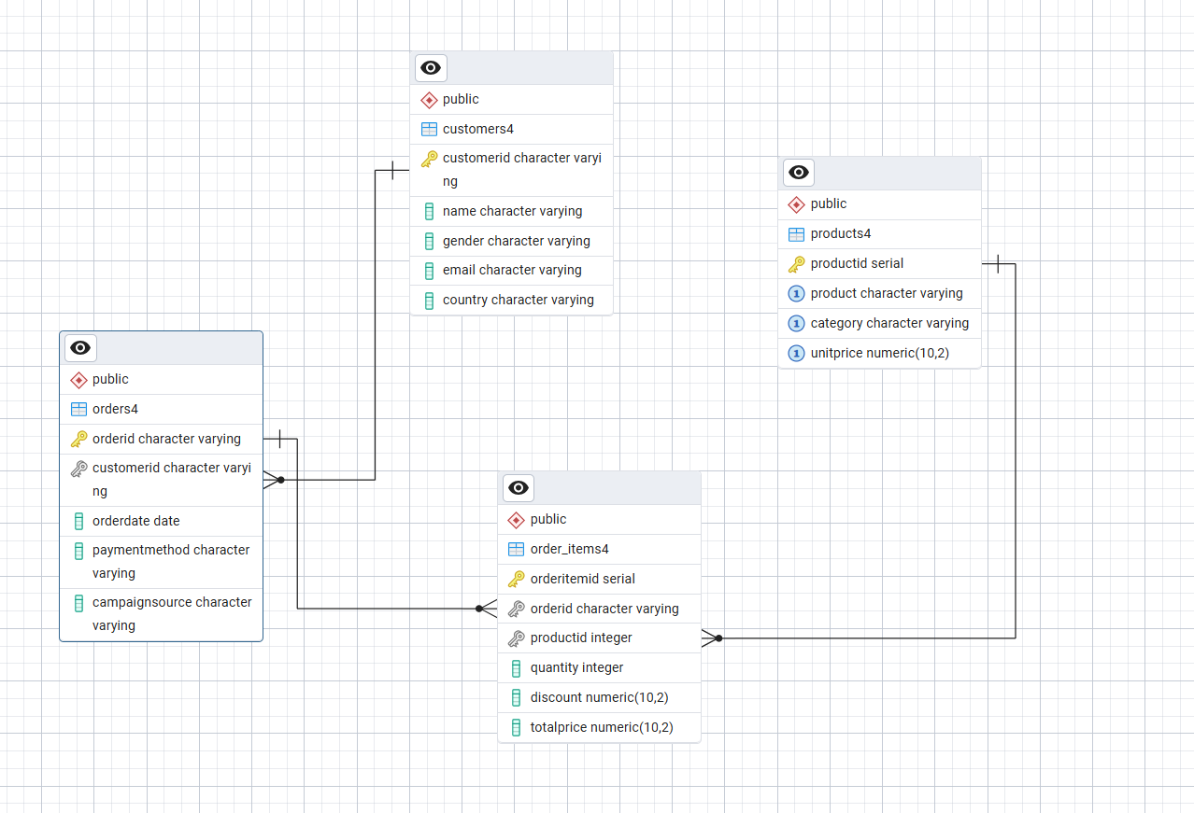

**SECTION 1: OVERALL BUSINESS METRICS**

**🔹 1.1 Total Revenue**

**Syntax:**



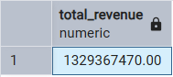

• **What it means**: Sum of all sales across all customers, products, and time.

• **Why it matters**: It's the most basic but critical KPI to measure business success.

• **Insight**: "How much money did the business actually make?"

**🔹 1.2 Total Orders**

**Syntax:**



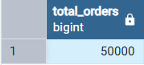

* **What it means**: Count of distinct order transactions.
* **Why it matters**: Indicates sales volume and order activity.
* **Insight**: "How many orders have been processed?"

**🔹 1.3 Total Customers**



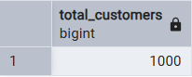

* **What it means**: Number of unique customers who made purchases.
* **Why it matters**: Helps understand customer base size.
* **Insight**: "How many unique customers have we served?"

**SECTION 2: PRODUCT PERFORMANCE**

**🔹 2.1 Top 5 Best-Selling Products (by Quantity)**

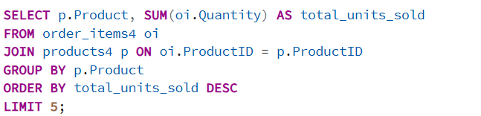

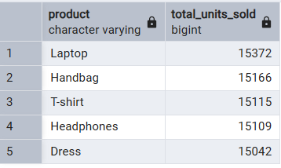

* **What it means**: Products that had the highest number of units sold.
* **Why it matters**: Identifies what’s most popular among customers.
* **Insight**: "Which products are in high demand?"

**🔹 2.2 Top 5 Products by Revenue**

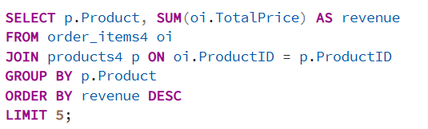

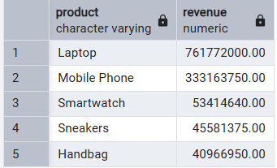

* **What it means**: Products that generated the most total revenue.
* **Why it matters**: Not all best-sellers are most profitable — this tells you which products bring in money.
* **Insight**: "Which products earn the most money for the business?"

**SECTION 3: CUSTOMER BEHAVIOR**

**🔹 3.1 Top 5 Customers by Spending**

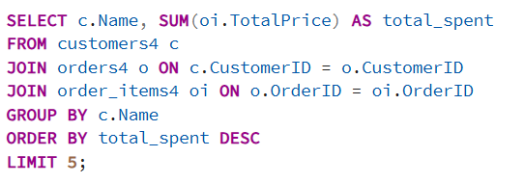

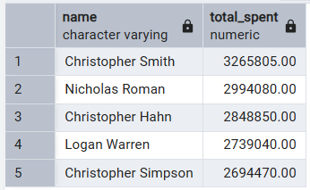

* **What it means**: Customers who spent the most on orders.
* **Why it matters**: Helps identify loyal or high-value customers (VIPs).
* **Insight**: "Who are our most valuable customers?"

**🔹 3.2 Revenue by Country**

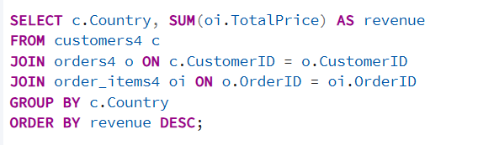

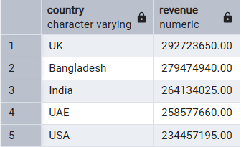

* **What it means**: Total revenue grouped by each customer’s country.
* **Why it matters**: Shows which regions drive the most business.
* **Insight**: "Which markets or countries should we focus on?"

**🔹 3.3 Revenue by Gender**

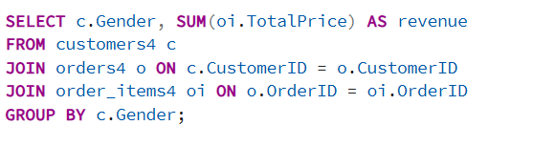

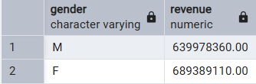

* **What it means**: Revenue breakdown based on gender.
* **Why it matters**: Helps understand which demographic contributes more to sales.
* **Insight**: "Do males or females spend more overall?"

**SECTION 4: MARKETING & PAYMENT INSIGHTS**

**🔹 4.1 Revenue by Payment Method**

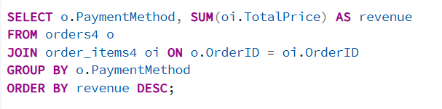

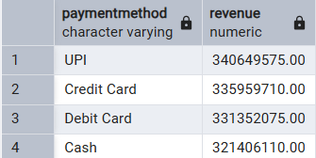

* **What it means**: Total revenue grouped by type of payment (Credit Card, PayPal, etc.).
* **Why it matters**: Tells you how customers prefer to pay.
* **Insight**: "Do we need to offer more payment options?"

**🔹 4.2 Campaign Performance**

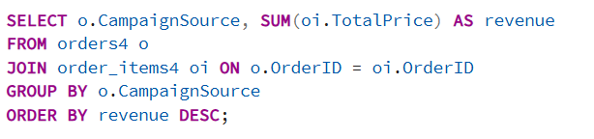

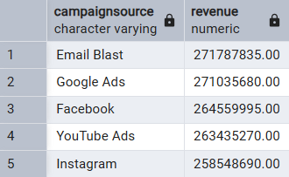

* **What it means**: Revenue grouped by campaign source (Google Ads, Email, etc.).
* **Why it matters**: Helps assess which marketing campaigns perform well.
* **Insight**: "Which campaigns generate the most revenue?"

**SECTION 5: SALES TRENDS OVER TIME**

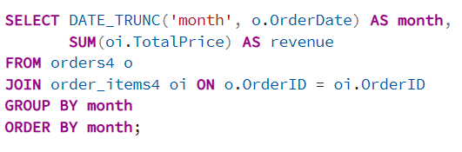

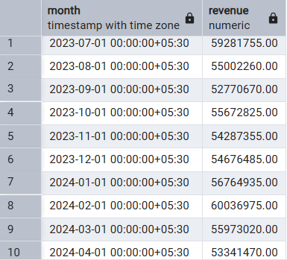

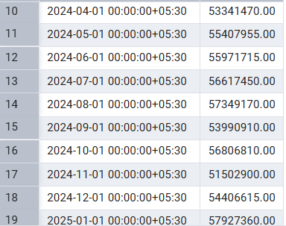

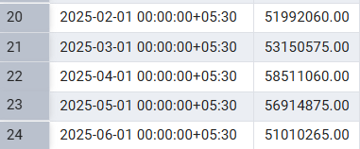

**🔹 5.1 Monthly Revenue Trend**

* **What it means**: Revenue summed up per month.
* **Why it matters**: Helps track sales performance over time.
* **Insight**: "Are our sales increasing or decreasing monthly?"

**Orders per Country**

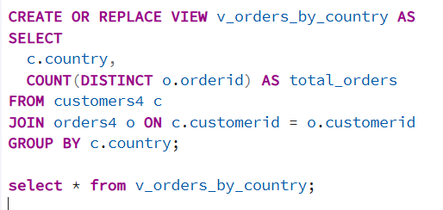

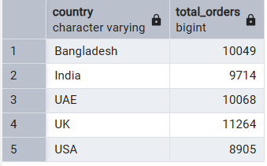

**Insight :**

* **India, USA, and UK** had the highest orders.
* This shows our sales and brand presence are stronger in these regions.
* Countries with fewer orders may need better marketing or service.

**Business Value:**

* Focus more on high-performing countries.
* Plan strategies to improve sales in low-order regions.

🔹💰 **Average Discount by Payment Method**

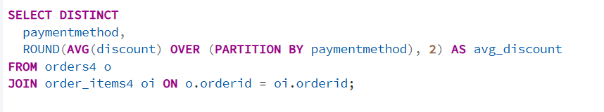

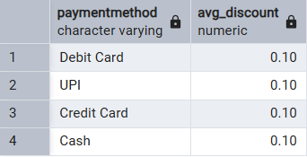

**Insight:**

* All payment types — **Debit Card, UPI, Credit Card, and Cash** — got the **same 10% discount**.
* This means customers get the same offer no matter how they pay.

**👉 What this tells us:**

* The discount rule is simple and the same for everyone.
* But the business can try giving **extra offers** for specific payment methods to:
  + Encourage people to use UPI or Debit Card
  + Save on payment processing costs

**Month-over-Month Revenue Growth %**

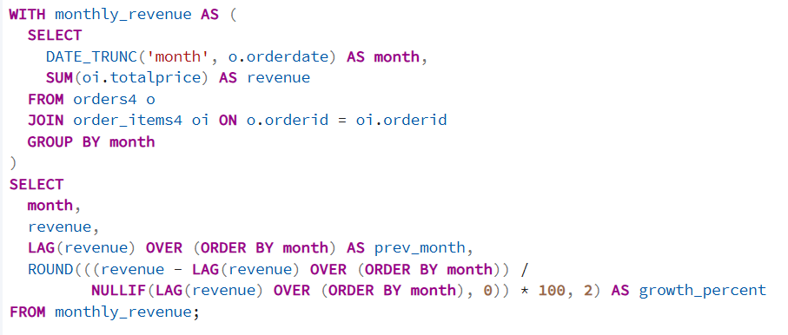

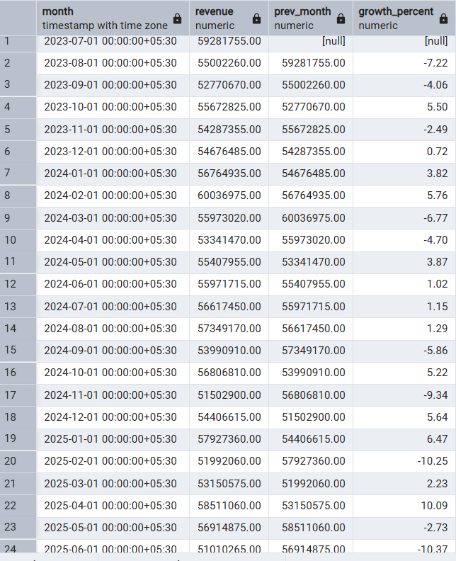

**Monthly Revenue Growth – Insight**

* I saw that revenue goes **up and down each month**, which means sales are not steady.
* **Good months** like **April 2025, January 2025, and February 2024** had strong growth.
  + This could be because of New Year offers, financial year-end sales, or good marketing.
* **Low months** like **Feb 2025, June 2025, and Nov 2024** had drops.
  + Maybe because there were no offers, less marketing, or low customer interest.

**What the business can do:**

* Look at what worked during the best months and repeat that.
* Run special sales or reminders in slow months to keep customers active.

📌 **2. Overall Avg Days Between Orders (All Customers)**

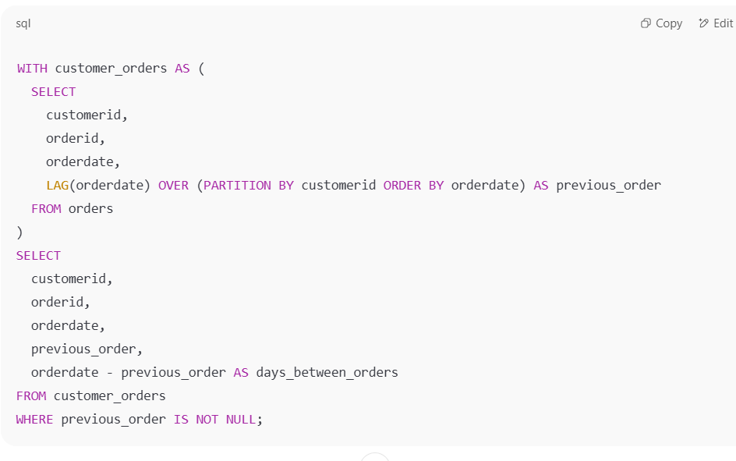

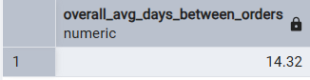

**Average Time Between Orders – Insight**

* On average, customers place their next order after **about 14 days**.
* This means many customers come back within **two weeks**.

**What this tells us:**

* People seem happy with the products and come back regularly.
* The business can use this to grow more sales by:
  + Sending offers or reminders after 10–12 days
  + Starting loyalty programs or even subscription plans

**Insights & Recommendations**

**1. Business Performance**

* Revenue and order volume are strong.
* Many active customers.
* Most orders are small but frequent.

**Recommendation:**

Keep offering affordable, fast-moving products and encourage repeat purchases.

**2. Best-Selling Products**

* Smartphones, T-shirts, sneakers, laptops, and headphones sell the most.
* Fashion and electronics are top-performing categories.

**Recommendation:**

Focus marketing and inventory on these items. Try bundle offers or upsell accessories to boost cart value.

**3. Customer Behavior**

* Top 5 customers contribute a lot to revenue and come from different countries.
* Male and female customers spend almost equally.

**Recommendation:**

Start loyalty programs for top customers. Give early access or exclusive offers to keep them coming back.

**4. Country-wise Sales**

* USA, India, and UK bring in the most sales.
* Other countries are growing but slower.

**Recommendation:**

Invest more in ads, delivery, and local offers for top countries. Explore new markets with customized campaigns.

**5. Monthly Sales Trends**

* Revenue is steady throughout the year.
* December has the highest sales due to holidays.

**Recommendation:**

Run major promotions from October to December. Use seasonal campaigns to boost sales.

**6. Campaign Performance**

* Google Ads and Email Marketing work best.
* Facebook and Instagram perform okay but can be improved.

**Recommendation:**

Continue investing in high-performing channels. Test and improve results on social platforms.

**7. Payment Experience**

* All payment methods give the same discount (10%).
* No method is being promoted specially.

**Recommendation:**

Make popular payment options more visible. Try offering extra discounts on low-cost methods like UPI to reduce cart dropouts.